## Hive DML commands

Hive DML (Data Manipulation Language) commands are used to insert, update, retrieve, and delete data from the Hive table once the table and database schema has been defined using Hive DDL commands.

The various Hive DML commands are:

### 1. LOAD Command

The ****LOAD**** statement in Hive is used to move data files into the locations corresponding to Hive tables.

If a ****LOCAL**** keyword is specified, then the LOAD command will look for the file path in the local filesystem.

If the LOCAL keyword is not specified, then the Hive will need the absolute URI of the file.

In case the keyword OVERWRITE is specified, then the contents of the target table/partition will be deleted and replaced by the files referred by filepath.

If the OVERWRITE keyword is not specified, then the files referred by filepath will be appended to the table.

****Syntax:****

LOAD DATA [LOCAL] INPATH 'filepath' [OVERWRITE] INTO TABLE tablename [**PARTITION** (partcol1=val1, partcol2=val2 ...)];

CREATE TABLE IF NOT EXISTS employee (

id int,

name String,

salary String,

designation String)

COMMENT 'Employee details'

ROW FORMAT DELIMITED

FIELDS TERMINATED BY ','

LINES TERMINATED BY '\n'

STORED AS TEXTFILE;

emp_data.txt:

emp_data.txt:

1,aaaa,45000,Technical manager

2,bbbb,45000,Proof reader

3,cccc,40000,Technical writer

4,dddd,40000,Hr Admin

5,eeee,30000,Oper Admin

LOAD DATA LOCAL INPATH '/home/dockershare/emp_data.txt' OVERWRITE INTO TABLE employee;

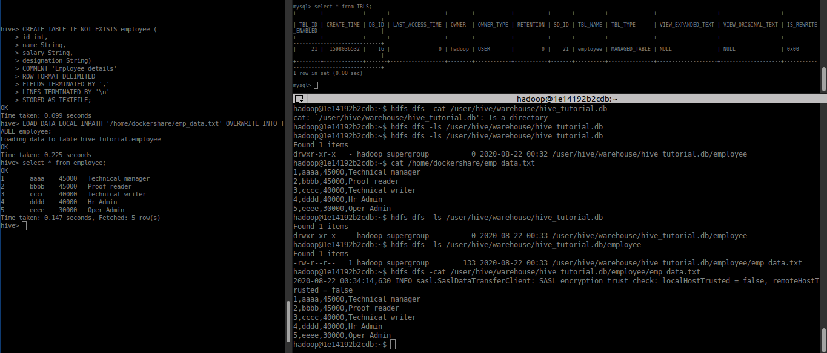

### 2. SELECT COMMAND

The SELECT statement in Hive is similar to the SELECT statement in SQL used for retrieving data from the database.

****Syntax:****

****SELECT [ALL | DISTINCT] select_expr, select_expr, ...****

****FROM table_reference****

****[WHERE where_condition]****

****[GROUP BY col_list]****

****[HAVING having_condition]****

****[ORDER BY col_list]]****

****[LIMIT number];****

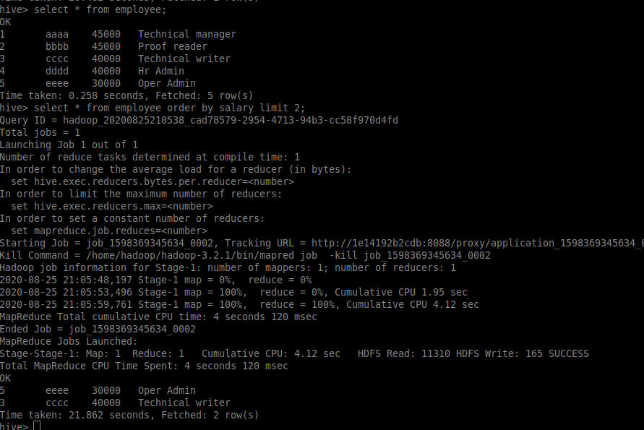

### 3. INSERT Command

The ****INSERT**** command in Hive loads the data into a Hive table. We can do insert to both the Hive table or partition.

#### a. INSERT INTO

The ****INSERT INTO**** statement appends the data into existing data in the table or partition. INSERT INTO statement works from Hive version 0.8.

****Syntax:****

INSERT INTO TABLE tablename1 [**PARTITION** (partcol1=val1, partcol2=val2 ...)] select_statement1 FROM from_statement;

#### b. INSERT OVERWRITE

The ****INSERT OVERWRITE**** table overwrites the existing data in the table or partition.

****Syntax:****

INSERT OVERWRITE TABLE tablename1 [**PARTITION** (partcol1=val1, ..) [IF NOT EXISTS]] select_statement FROM from_statement;

#### c. INSERT .. VALUES

INSERT ..VALUES statement in Hive inserts data into the table directly from SQL. It is available from Hive 0.14.

****Syntax:****

INSERT INTO TABLE tablename [**PARTITION** (partcol1[=val1], partcol2[=val2] ...)] VALUES values_row [, values_row ...];

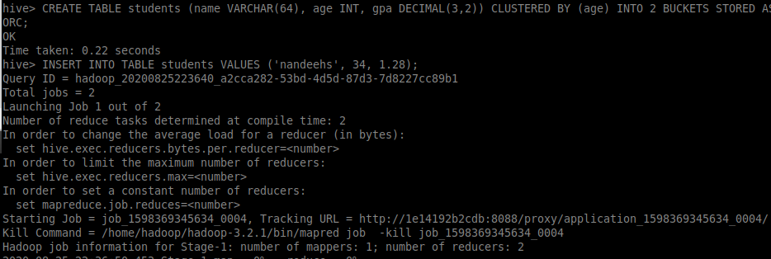

### 4. DELETE command

The DELETE statement in Hive deletes the table data. If the WHERE clause is specified, then it deletes the rows that satisfy the condition in where clause.

The DELETE statement can only be used on the hive tables that support ACID.

****Syntax:****

DELETE FROM tablename [WHERE expression];



Delete and update supported no ORC file only. Refer the link

<https://stackoverflow.com/questions/40677208/update-on-hive-1-2-1>

<https://sites.google.com/site/hadoopbigdataoverview/hive-errors-1/failed-semanticexception-error-10294-attempt-to-do-update-or-delete-using-transaction-manager-that-does-not-support-these-operations>

### 5. UPDATE Command

The update can be performed on the hive tables that support ACID.

The UPDATE statement in Hive deletes the table data. If the WHERE clause is specified, then it updates the column of the rows that satisfy the condition in WHERE clause.

Partitioning and Bucketing columns cannot be updated.

****Syntax:****

UPDATE tablename SET column = value [, column = value ...] [WHERE expression];



Delete and update supported no ORC file only. Refer the link

<https://stackoverflow.com/questions/40677208/update-on-hive-1-2-1>

<https://sites.google.com/site/hadoopbigdataoverview/hive-errors-1/failed-semanticexception-error-10294-attempt-to-do-update-or-delete-using-transaction-manager-that-does-not-support-these-operations>

Updating values of bucketing columns is not supported:





### 6. EXPORT Command

The Hive ****EXPORT**** statement exports the table or partition data along with the metadata to the specified output location in the HDFS.

Metadata is exported in a ****_metadata**** file, and data is exported in a subdirectory ****‘data.’****

****Syntax:****

EXPORT TABLE tablename [**PARTITION** (part_column="value"[, ...])]

TO 'export_target_path' [ FOR **replication**('eventid') ];





### 7. IMPORT Command

The Hive IMPORT command imports the data from a specified location to a new table or already existing table.

****Syntax:****

IMPORT [[EXTERNAL] TABLE new_or_original_tablename [**PARTITION** (part_column="value"[, ...])]]

FROM 'source_path' [LOCATION 'import_target_path'];

